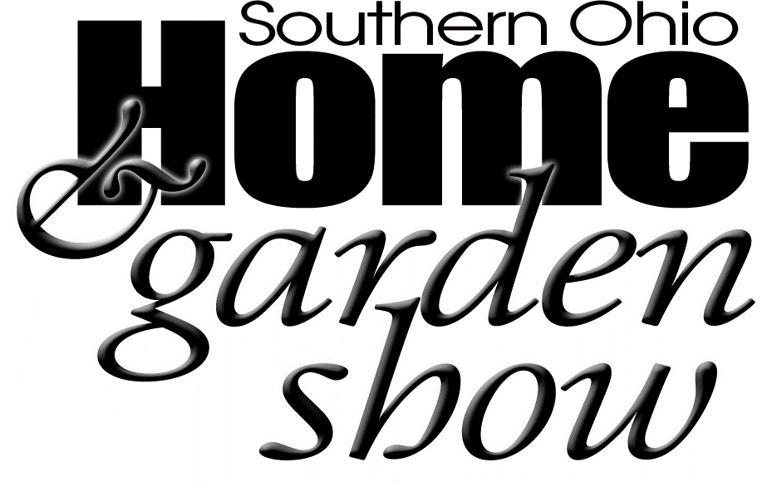
Event Sponsorship Opportunities
Platinum Sponsor (Limit of 8)
- Corporate name included on show advertising including but not limited to: posters, flyers, and show print ads
- 1- 8x10 booth ($275 value)
- 2-minute Facebook live feature on the Southern Ohio Home & Garden Show Facebook page
- Company name mentioned in a minimum of 8 advance publicity radio commercials
- Company website link at www.chillicotheohio.com through December 2018 (Under events tab)
- Recognition of event sponsorship in show signage and during the show
- Regular mentions on all social media platforms (Facebook, Twitter, etc.)
- Weekly mentions in Chillicothe Ross Chamber of Commerce newsletter publication
$750 ________
Gold Sponsor
- Company name mentioned in a minimum of 8 advance publicity radio commercials
- Company website link at www.chillicotheohio.com through December 2018 (Under events tab)
- Recognition of event sponsorship in show signage during show
- Regular mentions on all social media platforms (Facebook, Twitter, etc.)
- Monthly mention in the Chillicothe Ross Chamber of Commerce newsletter publication
$300 ________
Silver Sponsor
- Company website link at www.chillicotheohio.com through December 2018 (Under events tab)
- Recognition of event sponsorship in show signage during show
- Regular mentions on all social media platforms (Facebook, Twitter, etc.)
$100 ________
(enter sponsorship $ amount on page 1)
Company Name: _______________________________________________________________________
Contact Name: _________________________________________________________________________
Address: ______________________________________________________________________________
City: __________________________ State: _______________ Zip: _______________________________
Phone: _____________________ Fax: ___________________ Email: _____________________________
- Questions may be directed to the Chamber Staff at 740-702-2722 or bkellough@chillicotheohio.com

